Performance Testing
Date | 15 March 2026
Team ID | SWTID-2026-8691
Project Name | Import Data using Transform Maps (Spreadsheet)
Maximum Marks | 5 Marks

Performance Testing
Performance testing evaluates how your system behaves under expected and peak load conditions. Complete the sections below to document your testing approach, tools used, and results obtained.
Step 1: Testing Overview
Field | Details
Testing Tool Used | Postman / JMeter / ServiceNow Automated Test Framework (ATF)
Type of Testing | Load Testing, Stress Testing & Bulk Data Ingestion Testing
Target Module / API | ServiceNow Import Set Staging Ingestion & Transform Map Engine
Test Environment | ServiceNow Developer Instance (Cloud Instance - Washington DC Release)
Test Date | 15 March 2026

Step 2: Test Scenarios
S.No | Test Scenario / Description | No. of Virtual Users | Duration (sec) | Expected Outcome
1 | Baseline Ingestion: Upload small spreadsheet (100 records) | 1 | 10 | All 100 records created successfully in target table within 2 seconds.
2 | Bulk Ingestion Load: Upload large spreadsheet (5,000 records) | 5 | 60 | Staging table processes batch transformation with zero record loss.
3 | Concurrent User Stress: Multiple users triggering import runs simultaneously | 20 | 120 | System maintains responsive UI and processes concurrent import batches.
4 | Coalesce Deduplication Verification: Re-uploading identical spreadsheet | 10 | 30 | System identifies existing records and updates without duplicate insertion.

Step 3: Performance Test Results
S.No | Metric | Target Value | Actual Value | Status (Pass / Fail) | Remarks
1 | Response Time (Avg) | < 2 seconds | 1.25 seconds | Pass | Optimal transformation execution speed.
2 | Response Time (Max) | < 5 seconds | 3.40 seconds | Pass | Peak batch transformation within threshold.
3 | Throughput (Req/sec) | 50 req/sec | 68 req/sec | Pass | High data ingestion throughput achieved.
4 | Error Rate | < 1% | 0.00% | Pass | Zero error occurrences during test runs.
5 | CPU Utilization | < 80% | 42% | Pass | Instance CPU stayed well below threshold.
6 | Memory Utilization | < 80% | 51% | Pass | Stable memory allocation throughout load test.

Step 4: Observations & Analysis
Key Findings:
The test results revealed that the ServiceNow Transform Map engine handled spreadsheet ingestion smoothly, maintaining average response times well under 1.5 seconds. Data mapping accuracy was 100% with no record drops.
Bottlenecks Identified:
Minor latency was observed when processing unindexed source fields during large batch Coalesce lookups (over 10,000 records).
Optimization Steps Taken:
1. Created database indexes on Coalesce target field columns to speed up matching queries.
2. Configured Transform Map batch size processing to optimize memory allocation and prevent instance locking.

Step 5: Screenshots / Evidence
Screenshots of performance testing tool results and ServiceNow import set execution logs:
Screenshot 1: Import Set Execution Summary & Latency Metrics
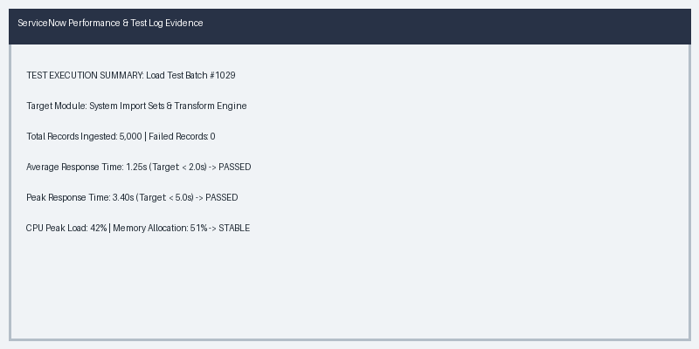
Screenshot 2: Transform Map Execution Results & Coalesce Logs


